

Carbon Reduction Plan

Supplier name: Access Anyone Limited

Publication date: Dec 2023

**Commitment to achieving Net Zero**

Access Anyone is committed to achieving Net Zero emissions by 2050.

**Baseline Emissions Footprint**

Baseline emissions are a record of the greenhouse gases that have been produced in the past and were produced prior to the introduction of any strategies to reduce emissions. Baseline emissions are the reference point against which emissions reduction can be measured.

|  |  |
| --- | --- |
| **Baseline Year: 2023** | |
| **Additional Details relating to the Baseline Emissions calculations.** | |
| New baseline  Scope 1 based on 7 vehicles, Total p/m  Scope 2 Electric 0.01830 kg per kwh, Gas 0.01830 kg per kwh | |
| **Baseline year emissions: 2023** | |
| **EMISSIONS** | **TOTAL (tCO2e) 4,836.16 kg** |
| **Scope 1** | 690.88 x 7 = 4,836.16 |
| **Scope 2** | Electric – 88.52 Gas – 166.70 |
| **Scope 3** | n/a |

**Current Emissions Reporting**

|  |  |
| --- | --- |
| **Reporting Year: 2024** | |
| **EMISSIONS** | **TOTAL (tCO2e) 4,828.11 kg** |
| **Scope 1** | 689.73 x 7 = 4828.11 kg |
| **Scope 2** | Electric – 87.84 Gas – 164.70 |
| **Scope 3**  **(Included Sources)** | n/a |

**Emissions reduction targets**

In order to continue our progress to achieving Net Zero, we have adopted the following carbon reduction targets.

We project that carbon emissions will decrease over the next five years, by 2030. This is a reduction of 0.0105%

Progress against these targets can be seen in the graph below:

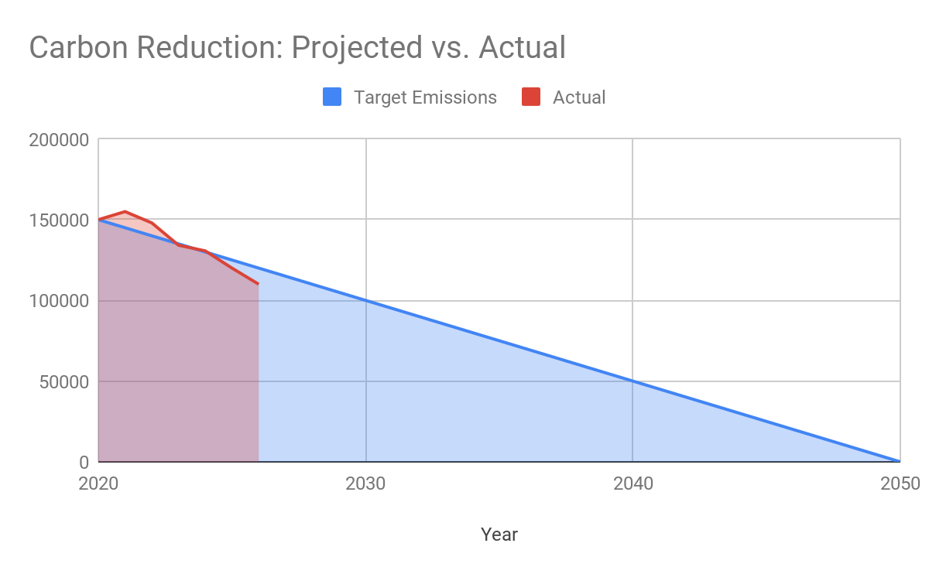

**Carbon Reduction Projects**

Completed Carbon Reduction Initiatives

The following environmental management measures and projects have been completed or implemented since the 2023 baseline..

Access Anyone has completed the following carbon reduction projects.

* Access Anyone’s head office in its entirety has taken the adoption of LED/PIR lighting controls.

In the future we hope to implement further measures such as:

* Use of more sustainable stationary.
* Combine deliveries.
* Encourage staff to car share where possible.

**Declaration and Sign Off**

This Carbon Reduction Plan has been reviewed and signed off by the board of directors (or equivalent management body).

**Signed on behalf of the directors:**

C Milligan

Date: Dec 2023